**Antiseptics and disinfectants**

In medical conditions, the process of destruction of all microorganisms is called sterilization, and the process of destruction of pathogenic microorganisms during sterilization is disinfection. Compounds used for this process do not have selectivity for microorganisms.

These connections are divided into two groups:

1) Those that are used for general disinfection: These compounds are used for disinfection of rooms, toilets, city water, waste water, hospitals and general residential premises. (Okhrana sredy = prevention)

2) Used for special disinfection: These compounds are substances that come into contact with the human body, such as clothes, medical instruments, hands, skin, mucous membranes and wounds. They are called disinfectants of special purpose (antiseptics).

Some of the pharmaceutical properties found in the second group of special-purpose disinfectants are as follows:

1) It should be possible to apply locally to wounds, mucous membranes and skin.

2) it must have the widest possible antimicrobial effect and must not develop resistance,

3) Sensitization should not be observed or it may be very insignificant

4) It must be stable

5) It must decompose in nature and not pollute the environment (bio-degradable).

6) It should not create an unpleasant smell around

7) The effect should be for a short time.

8) It should not have a toxic effect when it enters the body in any way.

9) The trigger will be used against all microbes and must have a long-lasting effect.

10) Blood should not inactivate serum preparations.

In addition to these properties, the binding kinetics of the antimicrobial drug is also an important condition. These compounds usually demonstrate first-order kinetics, and the time-concentration curve is flat. This kinetics depends on the speed, concentration, pH and region where the compound is applied. Time is the most important factor in determining kinetics. In general, fast kinetics is desirable. For example, the effect of 70% alcohol on the skin was determined as the destruction of 50% of bacteria on the skin in thirty seconds. Mathematical definition of kinetics is difficult because it depends on many factors, such as drug diffusion, microbial avidity, chemical and biochemical binding and distribution. Therefore, the speed of action of the disinfectant should not be directly dependent on the concentration. In general, the bactericidal effect is observed at the optimal concentration. For example, it is established that alcohol does not have an antiseptic effect at a concentration of more than 70%. There is a connection between thermodynamic activity and antimicrobial effect. As you know, the thermodynamic activity of drugs is related to the saturation of drugs in the environment. In this case, the medium limits the amount of the potent drug and a disorder occurs. The use of compounds with limited solubility, such as iodine and hexachlorophene, together with surface-active substances to increase thermodynamics proves the truth of this dependence. Primary tests are available to determine the effectiveness of the disinfectant and the suitability of the site. The most important characteristic of any disinfectant is its fast and antimicrobial action. Therefore, it is very important to determine the microbicidal effect of the test methods used. Standardized preparations are used in antimicrobial control. It is usually recommended to obtain standard bacterial strains from official collections.

Disinfectant activity: affects pH, chelating metal ions, macromolecules, other organic substances and especially waste detergents. Disinfectant activity is determined by the following equation. The constant of the test standard is directly proportional to the concentration and contact time of the preparation with the microbe.

**k=cŋt**

**с: hardness**

**t: find the duration of the effect**

**ŋ: concentration above**

**k: test constant**

Peak concentration at equilibrium (ŋ) is determined experimentally. Two concentrations of the disinfectant (с1 and с2) are determined with identical incubation and medium composition. The shortest destruction time (t1 and t2) is determined for each. The value of Ŋ is determined by the following equation.

Ŋ=logt2-logt1/logc1-logc2

Large top disinfectants have very narrow reliability. With them, the disinfection time increases in accordance with the dilution factor of the time subject to disinfection. As a rule, three different tests are conducted for the substance that will be used as a disinfectant.

1) In the phenolic test, the antimicrobial action of the compound is compared with the antimicrobial action of phenol. The amount of phenol that needs to be determined for this compound is compared with the amount of phenol that kills the microorganism in ten minutes, which gives the same result. Effective compounds must have a higher ratio of phenols. This method is carried out in a meat broth culture when the microbe is in contact with the preparation at 20 degrees. Staphlylococcus aereus, Salmonella typhi and Pseudomonas aeruginosa are usually used as microorganisms in these tests.

2) In another method, the disinfection curve of the disinfectant is compared with the disinfection value obtained with the standard solution of hypochlorite. The spray, which was used in practice as a germicide, is used as the only test in the standards of pharmaceutical products.

3) In the third experiment, microorganisms prepared instead of broth are introduced into a Petri bottle and dried at 37 degrees for 30-40 minutes. It is kept at room temperature for ten minutes.

The type of immediate external and internal disinfection of a person is called an antiseptic, and the compounds used are antiseptics.

Classification

Antiseptic compositions are divided into two groups: external (local) and internal (systemic) antiseptics.

External antiseptics

This group of connections is diverse in efficiency and stability. Among these compounds, the following characteristics show similarities and differences in one or several respects. In the ideal sense, there is no combination that combines all the following characteristics.

1) Good use and medical use

2) Spectrum of antimicrobial activity

3) incomplete property

4) Physical and chemical properties

5) Low toxicity

6) biodegradation function

7) Odor

8) Transportation

9) Economically profitable

External antiseptics have a completely different molecular structure. Classification according to their chemical structure is the most widely used method both commercially and scientifically.

1) Phenol

2) Aminoacridine

3) 8-hydroxyquinolines

4) Various compounds with nitrogen

5) Organic compounds of heavy metals

6) Quaternary ammonium compounds

7) Oxidizing compounds

9) Halogens

10) Depot of halogens

11) Halogenated organic derivatives

12) Hydrogen peroxide and active oxygen donors

13) Ozone

14) Preparations for chemical sterilization

15) Alcohol and aldehyde

16) Ethylene oxide and β-propionolactone

Comparison of the spectrum of action of various disinfectants listed in Martindale (Extra Pharmacopea), shown in the table.

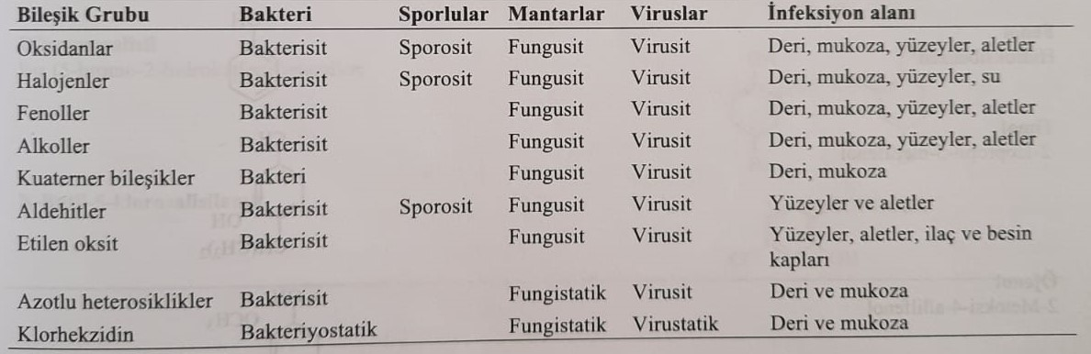

Mechanisms of antimicrobial action of disinfectants Microorganisms perform three main functions.

1) Influence on the cytoplasmic membrane. Для этого, denaturation of proteins that provide stabilization of the membrane occurs, and the process of peroxidation of lipids occurs.

2) Blockade of functional groups, such as carboxyl (-COOH), thiol (-SH) and amino (-NH2), found in enzymes of reproduction and vitality of microorganisms, denatures biopolymers and inhibits enzymes of vitality of microorganisms.

3) Violation of biosynthesis and function of nucleic acids of microorganisms occurs.

Most disinfectant compounds act in one or more of three ways, not just one. For example: organic and inorganic oxidizers oxidize mercapto groups in microbial biopolymers to disulfide groups. Superacid compounds also directly oxidize mercaptan groups of nucleic acids.

Acylamines (peptide bonds) and esters of phosphoric acid, which form the structure of microorganisms, are hydrolyzed by acidic or alkaline antiseptics that break down nucleic acids. At the same time, proteins, which are living material, are also denatured. Active halogens show the same activity. Organic compounds that oxidize heavy metals also irreversibly inhibit thiol groups contained in the proteins of microorganisms. Aldehydes denature proteins of microorganisms. The structure of N-methylol (-N-CH2OH), formed in this reaction, is a discontinuous compound that quickly forms a methylene bridge with a protein chain and causes protein denaturation. In fact, the same reactions are observed in proteins located in the plasma and in the inflammatory environment, and it is precisely for this reason that a decrease in the activity of aldehyde disinfectants develops during infections in an extremely inflammatory or blood-wound environment. Alcohols and phenols cause denaturation of membrane proteins of microorganisms, and quaternary ammonium compounds also cause disruption of the lipid membrane of bacteria.

**Phenol**

Phenol as a classic disinfectant compound was used by Leezer in 1867. As an antiseptic during surgical intervention, it received the name carbolic acid = phenolic acid. Phenol is also indicated in the pharmacopoeia and many national pharmacopoeias as a preservative in the production of vaccines and infusions. It is used in the form of a 3% solution for the denaturation of bacteria after the detection of bacterial culture, especially when toxins are formed. It was used as a disinfectant for people for some time, and its use was limited because of its toxic effect. Alkyl-, arylalkyl-, aryl- and halogenated phenols are more effective and less toxic. Phenol-based disinfectants are listed in the table below.

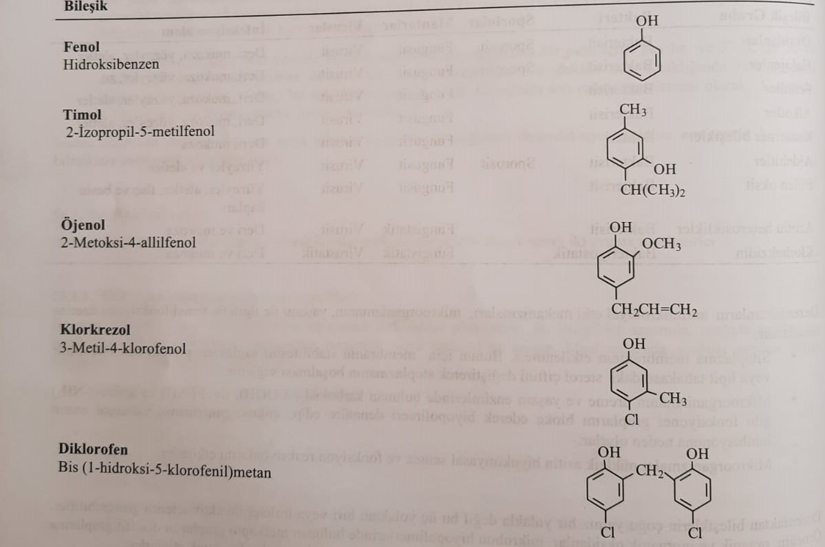

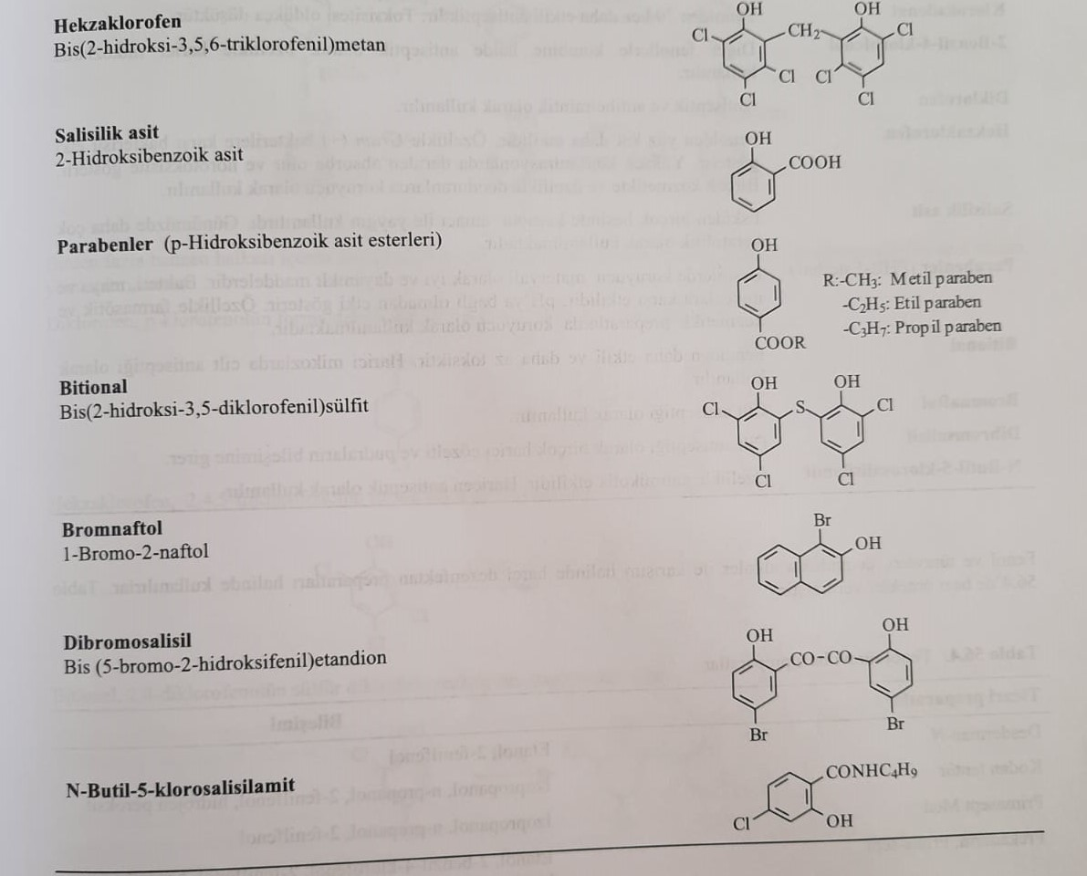

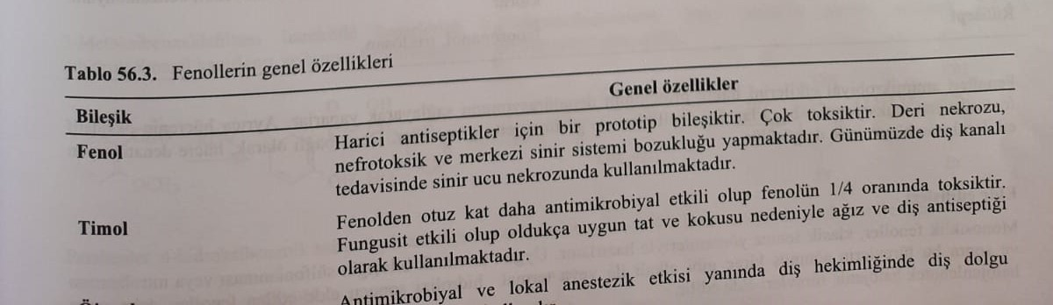

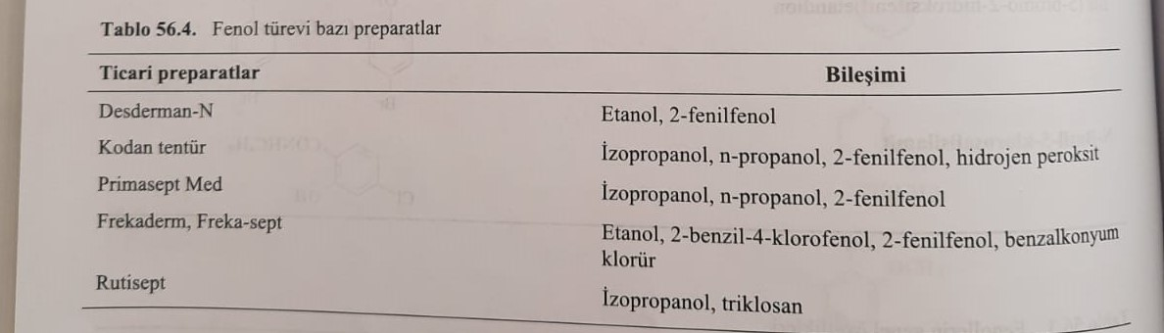

Phenols show an antimicrobial effect by denaturing cell membranes. At the same time, they provide oxidative phosphorylation of cells. These properties provide a bactericidal effect. Depending on the dose, these conditions are also observed in human cells.

Synthesis

Monocyclic phenols are obtained by classical methods of synthesis. Phenols obtained by sulfonation and nitrosation of the corresponding aromatic compound and subsequent hydrolysis of this derivative with the help of an alkali, such as slaked lime, or thermally, are then halogenated to obtain their halogenated derivatives.

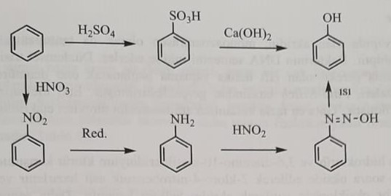

Dichlorophene, hexachlorophene, bitional, and dibromosalicilyl, which are derivatives that open up more than one benzene ring, have special synthesis methods.

Dichlorophene is obtained by condensation of p-chlorophenol in formaldehyde.

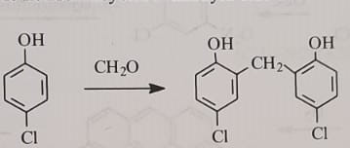

Hexachlorophene is obtained by condensation of 2,4,5-trichlorophenol with formaldehyde.

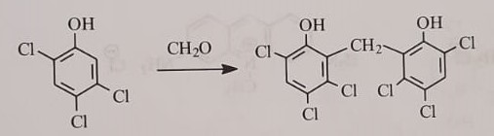

Bitional is obtained by the reaction of 2,4-dichlorophenol with sulfur dichloride.

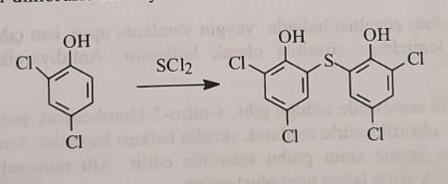

2,2,-Dihydroxybenzoin prepared from 2-methoxybenzaldehyde is oxidized with copper acetate to obtain 2,2,-dihydrobenzyl, and dibromosalicylin is obtained by bromination.

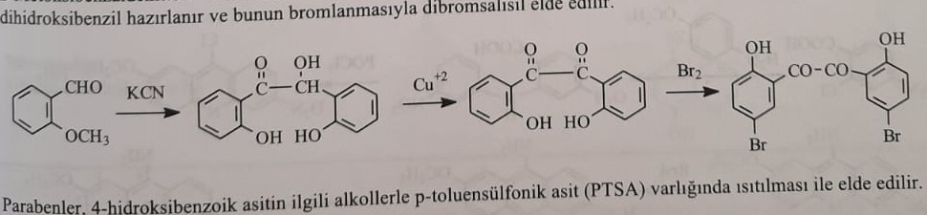

Parabens are obtained by heating 4-hydroxybenzoic acid with corresponding alcohols in p-toluenesulfonic acid medium.

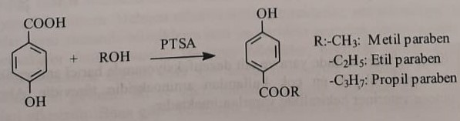

Aminoacridine

Acridine in the tricyclic heteroaromatic structure is called monoazoanthracene. Different derivatives possess greater antibacterial activity. They inhibit the synthesis of bacterial DNA. Being an amphiphilic cation of a sequential cyclic structure, they bind to the structure of the double helix, which is important for DNA replication, denature it and slow down the formation of bacterial RNA. The synthesis was conducted by Paul-Ehrlich. Mechanisms of action were discovered by Browning, Ehrlich's student. The most frequently used medicinal derivatives of aminoacrids are ethacridine and acriflavin.

acriflavina chloride

The compound is a mixture of 3,6-diaminoacridin hydrochloride and 3,6-diamino-10-methylacridinium chloride. For the synthesis of acriflavin, 4-nitrotoluene is oxidized by chlorination and 2-chloro-4-nitrobenzoic acid is obtained, which interacts with 3-nitroaniline. The resulting compound is heated with phosphorus oxychloride to obtain the acridine ring. Then they restore the nitro group to obtain acriflavin.

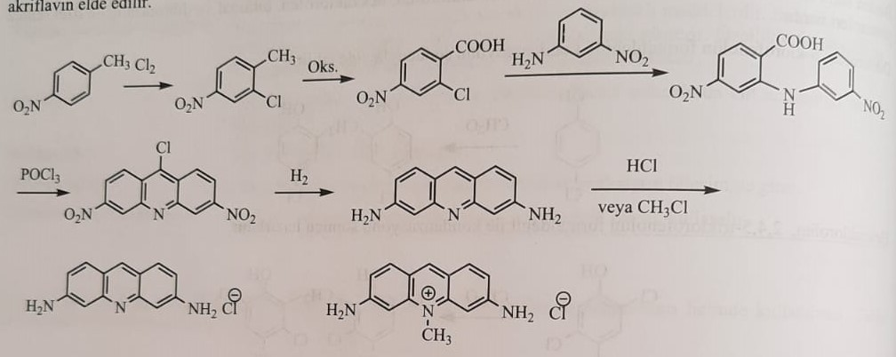

Etaridine lactate (Rivanol) :2-Ethoxy-6,9-diaminoacridine lactate

0.2% ointment, 0.05-0.1% aqueous solutions are used as antiseptics against abscesses, staphylococci and streptococci. It is also used for antidiarrheic purposes.

For the synthesis of ethacridine, as in the synthesis of acriflavin, 4-nitro-2-chlorobenzoic acid is introduced into the reaction with p-ethoxyaniline.

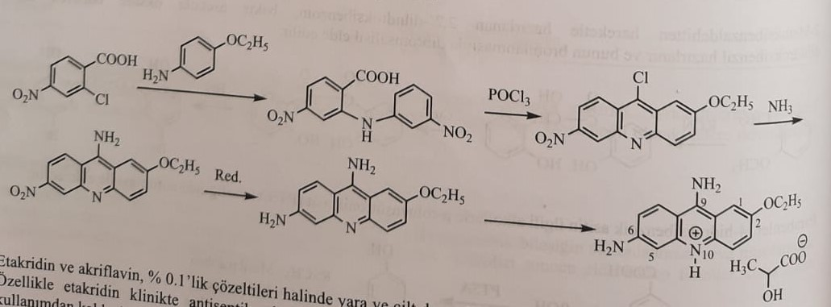

8-Hydroxyquinoline derivatives

The heterocyclic ring structure of quinoline is found in many chemotherapeutic compounds, mainly quinine alkaloid. An important example of these are 8-aminoquinoline, 4-aminoquinoline and quinoline carboxylic acid derivatives.

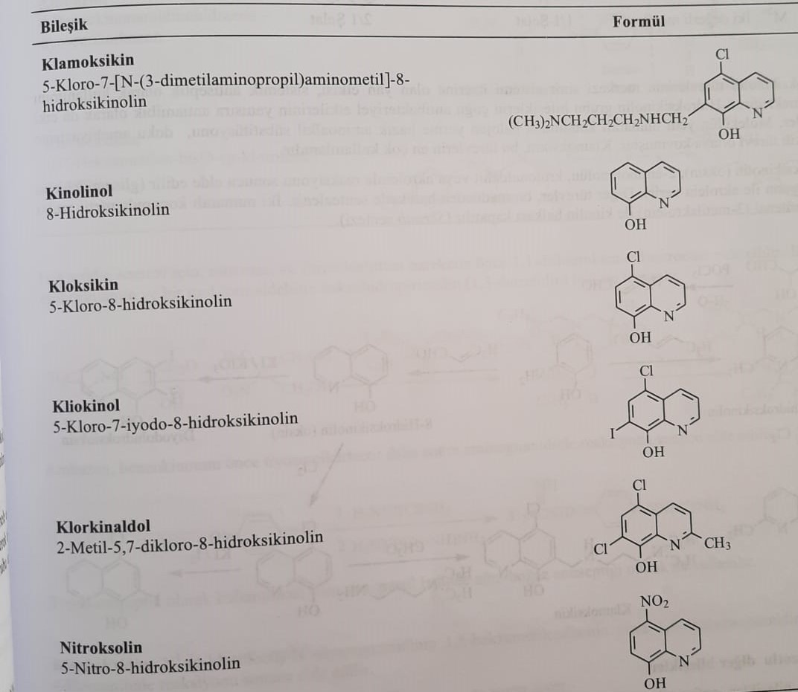

The main compounds of this group are 8-hydroxyquinoline, 4-aminoquinoline (antimalarial) and quinolonecarboxylic acid derivatives (gyrase inhibitors). 8-hydroxyquinoline (quinolinol) is a good antiseptic compound thanks to the phenolic group contained in it. In pharmaceuticals, halogen derivatives of 8-hydroxyquinoline are used as antiseptic compounds due to their more suitable physical and chemical properties.

The main compound of this group, 8-hydroxyquinoline, is soluble in water as a sulfate salt. Thus, its solubility in water allows you to prepare an antiseptic solution. Antibacterial activity of halogen products is in the order I>Br>Cl. Halogens also prevent oral and skin absorption of compounds. The pharmacophore of these compounds is 8-hydroxyquinolin. This group of compounds is primarily urinary antiseptics. They form a chelate with heavy metals, which play an important role in the cellular metabolism of bacteria. Processed chelate has a toxic effect on microorganisms. Antiseptic activity is not observed in derivatives with a combined hydroxyl group, except for the second and eighth positions. Therefore, it is possible to talk about the antiseptic activity of derivatives containing a hydroxyl group in two cases. They form a chelate with heavy metals, which form the active centers of enzymes necessary for the vitality of microorganisms. As a result, the active center of the enzyme undergoes configuration and cannot perform its function.

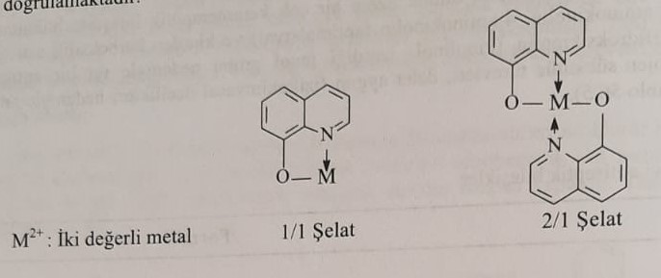

Side effects of 8-hydroxyquinoline derivatives on the CNS limit the systemic use of these drugs. In addition to the antibacterial effect of 8-hydroxyquinoline derivatives, antiamoebic effects are also observed. Adding an amino group instead of a halogen to the seventh position of the molecule leads to increased activity against amoebization. Clamoxixin belongs to them.

8-Hydroxyquinoline (oxine) is obtained from the reaction of 2-aminophenol with crotonaldehyde or acrolein. This substance is also used in the synthesis of other derivatives. In the second case, if the methyl group is present, the quinoline ring is closed with 2-butenal. (Scrub synthesis)

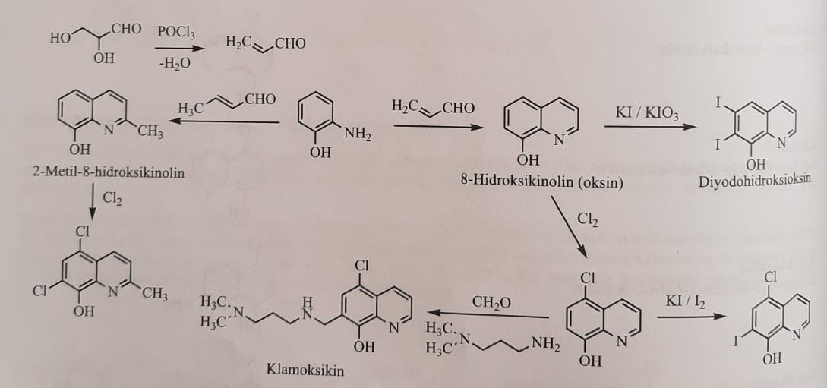 Nitrogen compounds

Some nitrogenous compounds have been introduced into clinical practice as antiseptics. These are generally used externally alone or in combination. Although there are many nitrogenous compounds, hexetidine (hexahydropyrimidine), ambazone and chlorhexidine are used in medical practice.

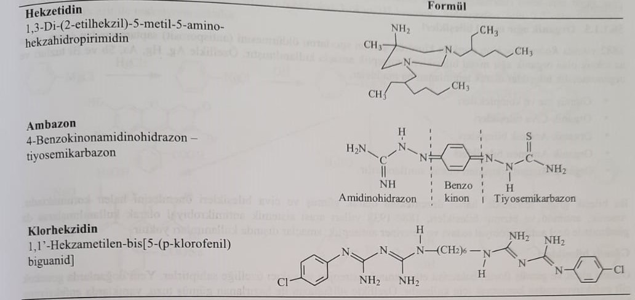

Hexetidine is a nitrogen-saturated heterocyclic compound of hexahydropyrimidine structure. This is an important antiseptic used in recent years. Branched alkyl groups are attached to nitrogen atoms in the 1,3-diazetidine ring. 1,3-diazetidine has a methyl group and an amino group in the fifth position of the structure. Thus, the compound is chemically amphoteric. As a result of the addition of formaldehyde to 1.3 nitrogen atoms of the structure, a ring of diethidine with an amino structure is formed. It is applied externally as a 0.1% solution.

1,1-di(hydroxymethyl)nitroethane is obtained by using nitroethane and formaldehyde for the synthesis of hexetidin. Two moles of 2-ethylhexylamine and one mole of hexahydropyrimidine (diethidine) ring are obtained.

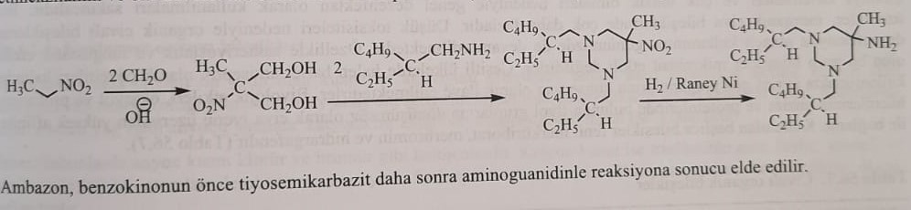

For the synthesis of ambazone, the reaction of benzaquinone first with thiosemicarbazide and then with aminoguanidine is used.

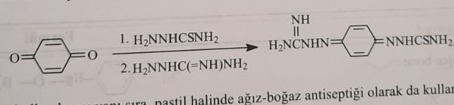

In addition to being used as a topical antiseptic, it is also used in the form of lozenges.

Chlorhexidine: obtained by the reaction of N1-(p-chlorophenyl)-N3-cyanoguanidine with 1,6-hexamethylenediamine or 1,6-di(cyanoguanidine)hexane with 4-chloroaniline.

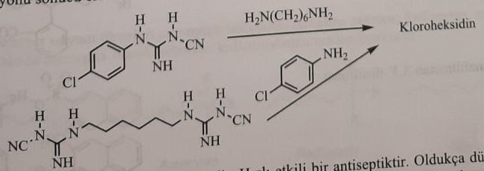

Chlorhexidine is a biguanide derivative of bisparachlorobenzene. This is a fast-acting antiseptic. It has very low toxicity. It is used in the form of a 0.2% solution for surgical interventions and as an antiseptic for angina. It is used for rinsing the throat, especially when the microflora of the oral cavity is disturbed. This causes the teeth to turn brown. It is applied externally in the form of ointment, cream and gel. It is intended for external use in many pharmaceutical preparations.

Organic compounds of heavy metals

In 1882, after Robert Koch discovered that sulema destroys anthrax spores, organometallic compounds with low toxicity were synthesized. In particular, Ag, Hg, As, Sb and Bi salts are used for these purposes.

1) Silver salt and complexes

2) Mercury compounds

3) Organo-arsenic compounds

4) Organo-antinomous (stibia) compounds

5) Organo-bismuth compounds

In this group of compounds, silver and mercury compounds still retain their importance as external disinfectants. Although compounds of arsenic, antimony, and bismuth were used as systemic antimicrobial agents in the period from 1880 to 1938, they are no longer used as disinfectants. These compounds, especially used as bacteriostatic and fungistatic means, do not have bactericidal efficacy. It is still used in different countries. Their biological action consists in irreversible binding with thiol groups of enzymes of prokaryotic and eukaryotic cells. The main compounds used are phenylmercury borate, merbrom and hydragafen.

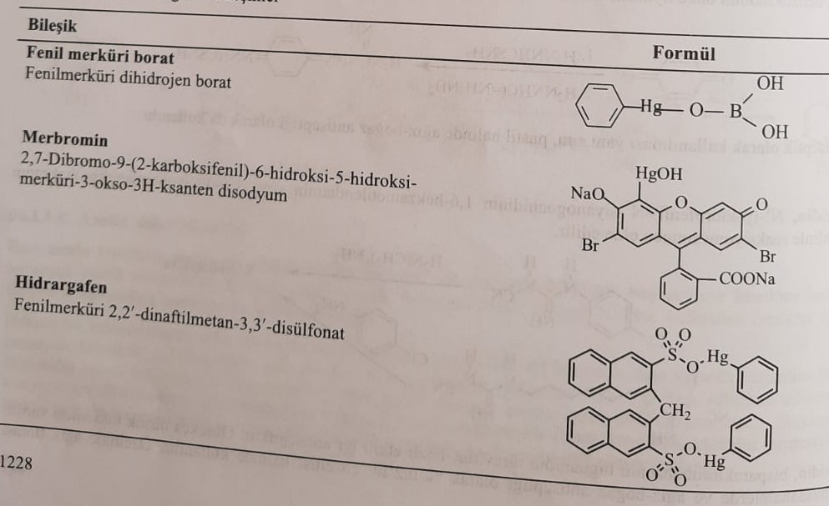

The main substance of organic mercury compounds is phenylmercury hydroxide. Phenyl mercuric hydroxide is obtained from the reaction of phenyl magnesium chloride with mercuric chloride in an alkaline medium. The processed product is boric acid for phenyl mercuric borate, 2,7-dibromo-9-(2-carboxyphenyl)-6-hydroxy-3-oxo-3H-xanthene for merbromine, and 2,2,-dinaphthylmethane-3, for hydrargaphene. It is introduced into the reaction with 3,-disulfonic acid.

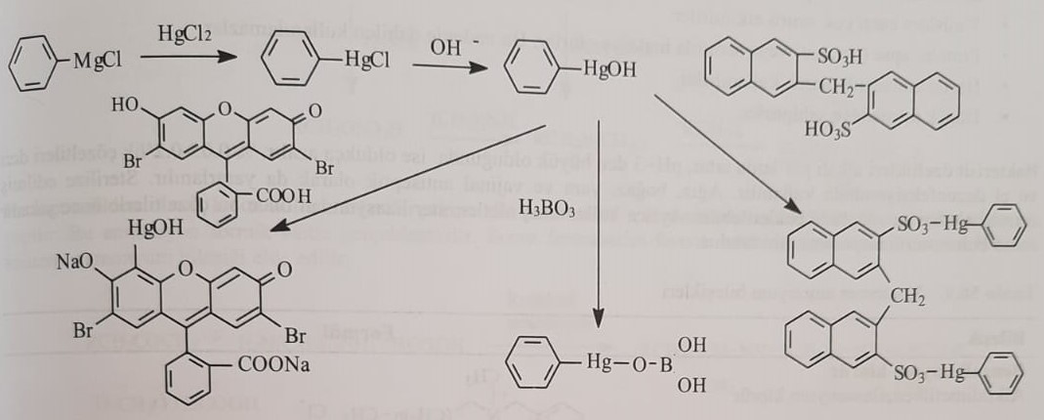

0.5-1% solutions of compounds are used externally. Because absorption is observed in open wounds, its use in open wounds is limited to avoid toxicity.

Quaternary ammonium compounds

Quaternary ammonium compounds, which are an important group in disinfection, are surface-active compounds that exhibit cation-active colloidal active properties in contrast to anion-active soaps. For this reason, these compounds are called invert soaps. In soaps, along with long-chain fatty acids, cations are formed by base or alkaline earth metals.

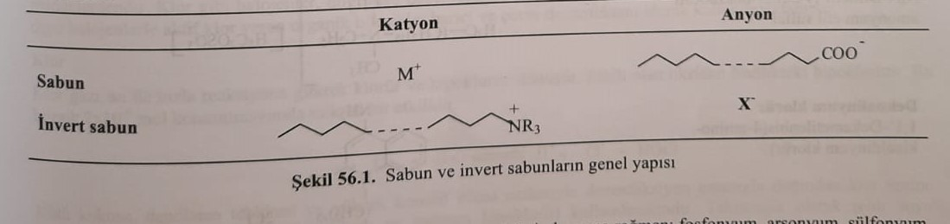

The most commonly used quaternary ammonium compounds include onium compounds such as phosphonium, arsonium, and sulfonium.

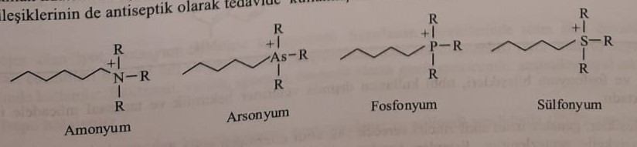

The most commonly used quaternary ammonium compounds for external disinfection purposes in clinical practice are shown in the table below. The pharmaceutical properties to which these compounds correspond are as follows:

1) A bactericidal effect is observed when the lipophilic alkyl chain has 8-10 carbons.

2) They do not affect Mycobacterium and its spores.

3) They have a limited effect against viruses.

4) They pass into an inactive form with protein, abscess and plasma. Therefore, internal use is limited.

5) It is used as an external antiseptic.

6) It has low toxicity.

Bactericidal effects increase in an alkaline environment, activity is lost when pH drops below 3. It is used for hand disinfection purposes in the form of 0.05-0.2% solutions. It is also used in inflammatory diseases of the mouth and throat. At the same time, it is used for the purpose of sterilization of medical instruments.

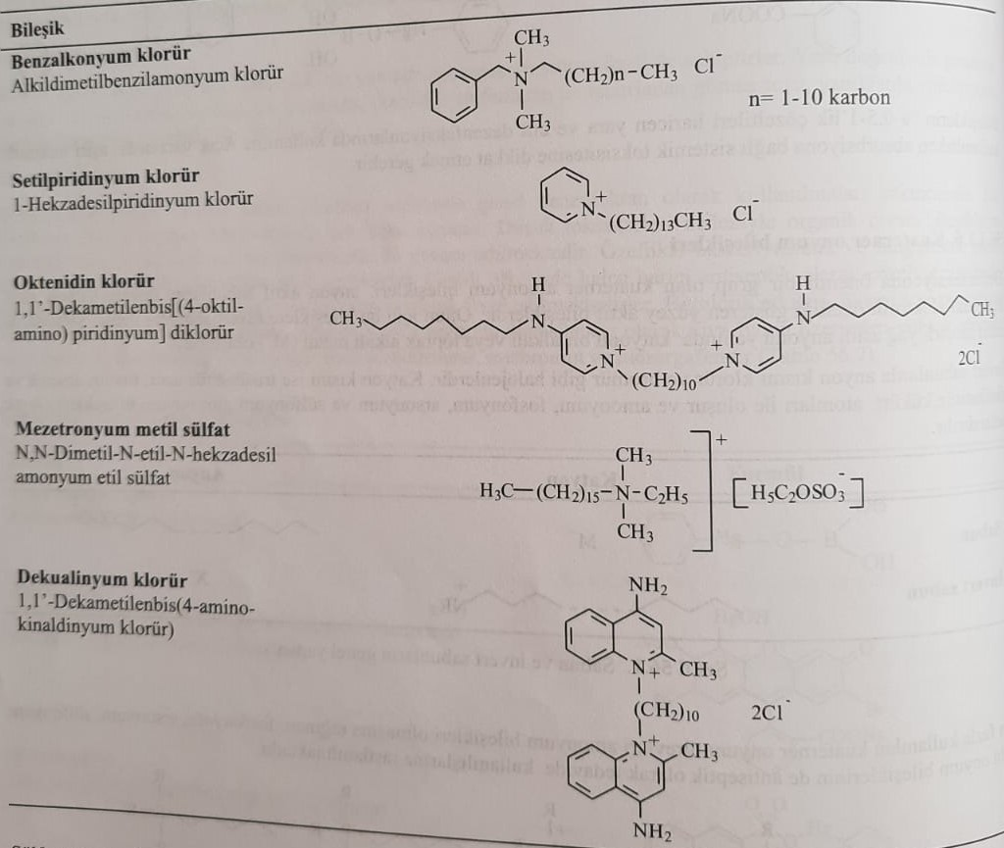

In addition to medical practice, sulfonium and phosphonium compounds are also used in veterinary and agricultural fields.

These compounds are generally synthesized using fatty acid esters that will yield a long alkyl chain or a related ketone bearing a branched alkyl chain. When an ester is used, the first alcohol is reduced with lithium aluminum hydride. The alcohol derivative is converted to an amine with dimethylamine, or after preparation of the sulfate ester of the alcohol derivative in sulfuric acid, it is converted to a triple amine group with dimethyl amine. A quaternary amine group is formed as a result of the reaction of a ternary amine group derivative with an alkyl halide.

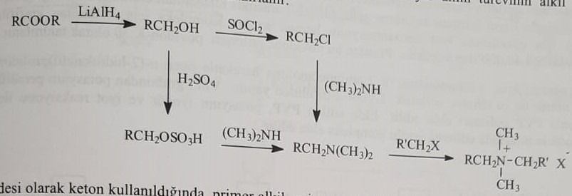

When a ketone is used as a starting material, it is subjected to reductive amination with monoalkylamine or 1,12-dodecanemethylenediamine. This amination takes place with formic acid. Then formaldehyde-formic acid triple amine and methyl chloride with quaternary ammonium compound are obtained.

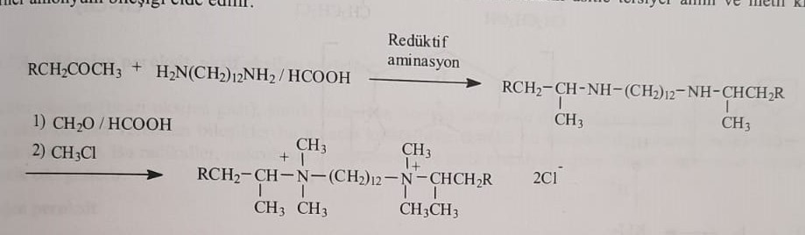

Oxidizing compounds

The first compounds used in medicine for the purpose of disinfection are oxidant compounds. In this group of compounds, the oxidizing property of oxygen is used. It is established that anaerobic bacteria cannot multiply in an oxygen-saturated environment. Halogens and active halogen donors are also used as oxidizing agents, just as active oxygen donors such as ozone and peroxides are used.

halogens

Gaseous chlorine has been used to disinfect drinking water since ancient times. Halogens, such as chlorine, are used directly as antiseptics. Iodine and povidone-iodine compounds are used as depot antiseptics.

chlorine

Gaseous chlorine quickly reacts with water with the formation of hydrochloric and hydrochloric acids. Hydrochloric acid has an oxidizing effect. This compound has a microbicidal effect at a concentration of 2×106 mol.

Cl2+H2O=HCl+HClO

Hydrochloric acid is used instead of chlorine because it has an unpleasant smell and is dangerous when stored. Technically, this acid is widely used in urban water purification.

Iodine

Iodine, a solid halogen, dissolves in water when mixed with potassium iodide. It is used as an antiseptic in alkaline solutions, in the form of mixtures with ethanol and glycerin. It has bactericidal, virulicidal and fungicidal action.

Depot Halogens

Complexes of iodine with amphiphilic polymers are called iodophors, and the complex form with polyvinylpyrrolidone is used in medical practice.

Povidone-iodine (iodine-PVP)

It is used to sterilize skin, mucous membranes and medical instruments. The main compound, povidone-iodine complex, contains 10% iodine. This percentage means that the solution contains 1% iodine. The maximum effect is observed at Ph=2-7. The amphiphilic polymer used for the complex has a molecular size of less than 40,000. In practice, this povidone polymer is called povidone-K.30.

Using γ-butyrolactone and 2-aminoethanol for the synthesis of povidone-iodine, n-(2-hydroxyethyl)prolidin is obtained. Then get 1-vinyl-2-pyrrolidine by removing water with thionyl chloride. Polymer PVP is obtained as a result of radical polymerization of vinyl group with potassium persulfate. The obtained PVP is subjected to interaction with potassium iodide and iodine to obtain povidone-iodine (Iosept).

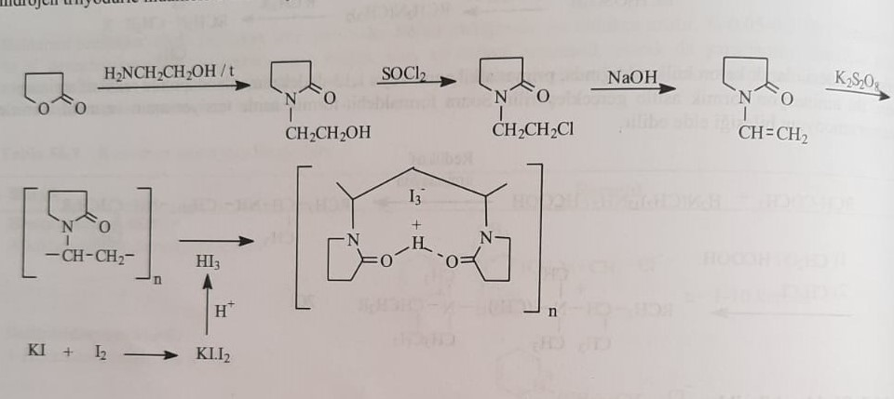

Chlorinated organic compounds

Cream of lime and alkaline hypochlorides are referred to as environmental disinfectants. Chlorinated organic compounds are also used as controlled chlorination compounds due to their less aggressive properties and durability. These are called organic hypochlorides. Chloramine-T, dichloramine-T, and halazone are the most commonly used substances in practice.

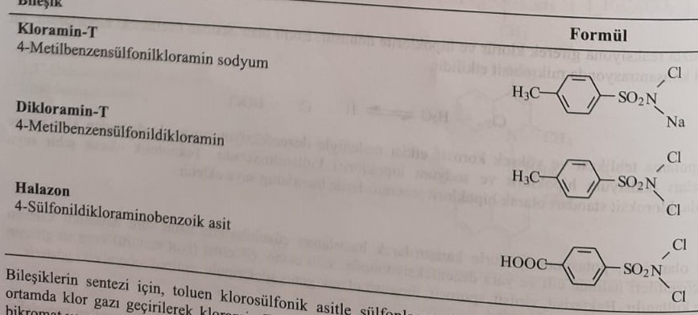

For the synthesis of compounds, chlorosulfonic acid is sulfated. Ammonia gives p-toluenesulfonamide. Chloramine-T and dichloramine-T are obtained by passing chlorine gas in an alkaline environment. The methyl group of p-toluenesulfonamide is oxidized with potassium bichromate and potassium permanganate to obtain chalazone.

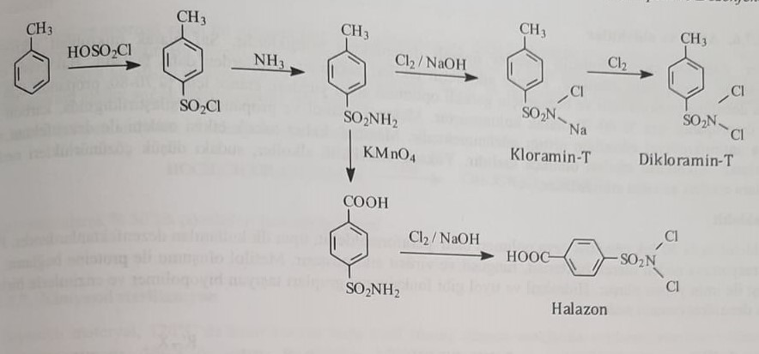

Hydrogen peroxide and active oxygen donors

Molecular oxygen is not used as a disinfectant because of its limited reactivity. Because the oxygen formed from these compounds is an extremely reactive radical oxygen. These radicals quickly react with microbial biopolymers. It also has an antiseptic effect on many microorganisms.

Hydrogen peroxide

Hydrogen peroxide is split into water and oxygen by the enzyme catalase, which is present in all living cells. The smell is lead and bleach. But the duration of the effect is very short. In practice, they use a 30% solution called perhydrol. At the same time, it is used as a 3% solution for washing wounds and gargling.

Hydrogen peroxide is obtained by acidifying metal peroxides.

BaO2+H2SO4=H2O2+BASO4

In practice, it is obtained from barium peroxide. In recent years, 50% solutions have also been included in practice for the purpose of disinfection.

Potassium permanganate (Marganisovka)

A diluted solution of 1:10000 is used. It is used for disinfection of wounds and mucous membranes. Prevents the occurrence of inflammatory reactions. It is often used in veterinary medicine.

Inorganic and organic peroxides

Monoperoxysulfuric acid, monoperoxysuccinic acid and perbenzoic acid are antiseptics used in medical practice. In addition to the antibacterial effect, an antiviral effect is also observed. It is also used in the treatment of acne.

Ozone

This is a highly active disinfectant. However, its use is limited due to high toxicity and economic inefficiency. It is mainly used for disinfection of cosmetic and pharmaceutical products.

Alcohol and aldehyde

Alcohols, especially monohydroxy alcohols, are important disinfectants. Purely microbicidal effects vary depending on the concentration. Monoatomic alcohols are more effective than diatomic alcohols. Bactericidal effects occur due to the denaturation of proteins, and the percentage of alcohol required for this is 70-80%. They compared methanol, ethanol and propionol alcohols, and antiseptic properties increase when the length of the chain is increased. The persistent toxic effect of methanol limits its use as an antiseptic. Higher alcohols are unable to show antiseptic activity due to reduced solubility in water.

Formaldehyde

Paraformaldehyde, a 30% solution and polymer formaldehyde, was the first antiseptic used in medical practice. They show their effects due to protein denaturation. It causes the denaturation of these biopolymers by combining with enzymes and proteins that preserve the hydroxyl or thiol group.

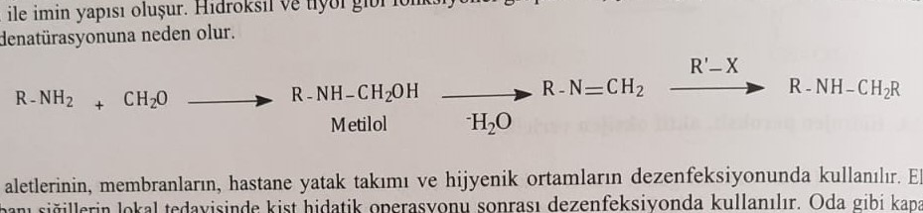

It is used for disinfection of dialysis instruments and various equipment. Normally, 6 moles of formaldehyde are stored together with 4 moles of ammonia. 30 grams of a 35% solution is a lethal dose.

The acute toxic effect causes necrotic wounds in the mouth and throat. First of all, the patient is given milk against poisoning. The patient's intoxication is treated symptomatically by transferring sodium bicarbonate infusion intravenously. Prodrug forms are used to take advantage of their antiseptic properties.

Methenamine: Hexamethylenetetramine

It is also known as urotropin. Formaldehyde is a prodrug. It is used against sweating.

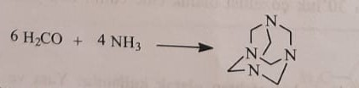

Taurolidine: 4,4,-methylenebis(hexahydro-1,2,4-thiodiazine-1,1-dioxide)

It is a good antiseptic, acting against many aerobic and anaerobic bacteria by providing iminium ion. It is used in the form of 0.5-2% solutions for local blood infections. Because the application is painful, it takes place under anesthesia.

The synthesis of taurolide is as follows:

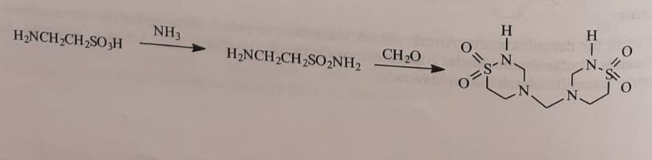

Gluteraldehyde

It is a bactericidal, virucidal and sporicidal drug. It acts faster and is less toxic than formaldehyde. Gluteraldehyde synthesis is as follows:

Internal antiseptics

They are mainly used in urinary and digestive system infections. These are mainly bacterial, viral, helminth, protozoan infections. Systemically effective antiseptics include:

1) Organic arsenic compounds

2) Organic stibium compounds

3) Organic bismuth compounds

4) Nitrofuran derivatives

Organic Arsenic Compounds

Inorganic arsenic compounds have been used in medical practice for over 2,500 years. However, its use is limited due to extreme toxicity. Arsenic occurs in nature as trivalent and pentavalent inorganic compounds. However, organic arsenic compounds are relatively less toxic compounds. Organic compounds of arsenic are mainly used as systemic drugs in urinary and gastrointestinal tract infections. In the body, pentavalent arsenic is converted to trivalent arsenic by NADFH, and this is how the drug exerts its effect. Arsenic organic compounds are listed in the table below.

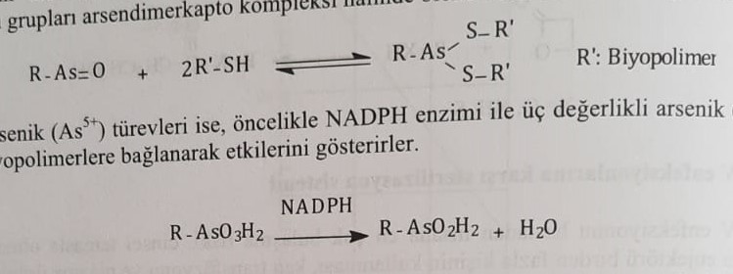

Currently, arsenic compounds are not used in the treatment of syphilis infection. It is mostly used in veterinary practice.

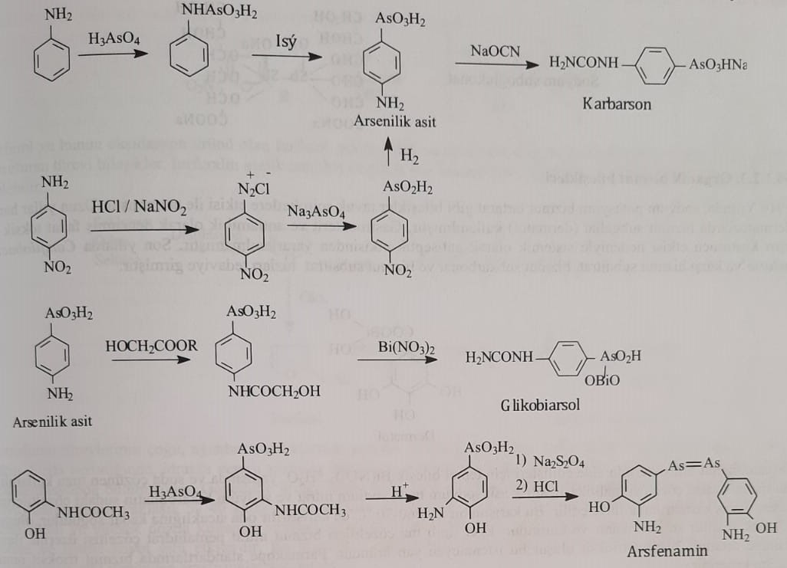

Dimercaprol (BAL, British Anti Lewisite) is used in case of acute poisoning caused by systemic drugs. The synthesis of the compounds is shown below.

Melarsoprol is synthesized as follows.

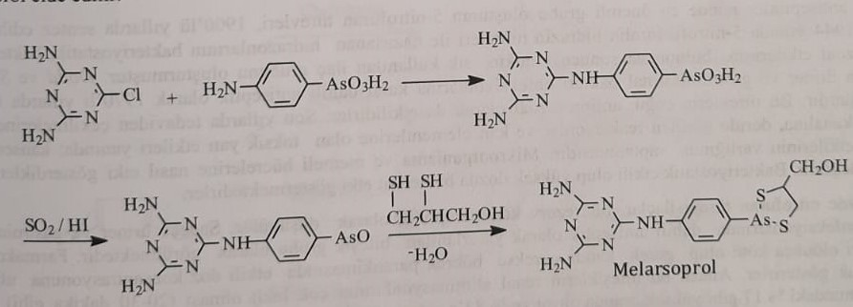

Organic stibium compounds

Similar to arsenic compounds, organic stibium compounds also affect proteins and other biopolymer systems. At the same time, the drug has an emetic effect. Sodium stibiogluconate belongs to this group.

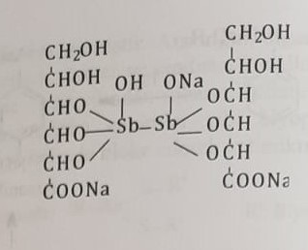

Organic Bismuth Compounds

In 1916, the effect of sodium potassium bismuth tartrate compound on chicken spirochetes was noted. In recent years, bismuth subnitrate, bismuth subcarbonate and bismuth subcitrate have been used against Camfilobacter pylori infection. Dermatol belongs to this group of compounds.

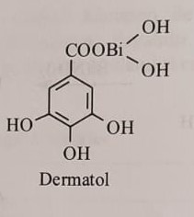

Nitrofuran derivatives

Derivatives of 5-nitrofuran are the most important group of systemic antiseptics. Although it was synthesized in 1900, in 1944 presence of bactericidal, bacteriostatic and antiprotozoal action in hydrazones obtained from hydrazine derivatives of 5-nitrofuran increased clinical interest. Introduced by Dodd and Stillmann in 1970 as an internal antiseptic against urinary and gastrointestinal infections. Many of these derivatives have antiprotozoal activity. In recent years, he was withdrawn from treatment due to toxic side effects observed in the digestive tract and skin. How they affect microorganisms and mammalian cells is still unknown. They are bacteriostatic and in high doses have a bactericidal effect.

Currently, nitrofuran derivatives are considered as reserve chemotherapeutic agents. It is planned to be used only for urinary and digestive infections. Poor pharmacokinetic properties are the reason for its limited use. However, the excretion of these compounds by the kidneys occurs very quickly and 83% accumulates in the Gelni loop. Therefore, it is still relevant in the clinic.

Another disadvantage of nitrofuran derivatives is very low absorption when administered orally. In some derivatives, difficulty in absorption causes their repeated inclusion in the gastro-hepatic circulation, which leads to the accumulation of the drug in the gastrointestinal tract. These preparations are also used as gastrointestinal antiseptics. About 90% of systemic antiseptoils with nitrofuran derivatives are excreted unchanged in the urine. But the remaining part is subjected to the reduction of the nitro group by the oxidation and reduction reactions of phase I and an anion-radical is formed. As the first stage, anion-radical formation is observed. This anion forms an active cytotoxic oxygen radical in anaerobic conditions and oxidizes to nitrofurantoin.

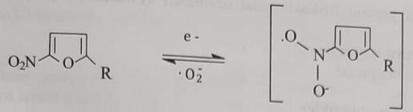

Furfural and its oxidation product furfural are obtained by direct distillation of sugar, wood and cellulose. Nitrofuran is a derivative compound. 5-nitrofurfural diacetate is formed from the reaction of furfural with acetic anhydride and nitric acid mixture.

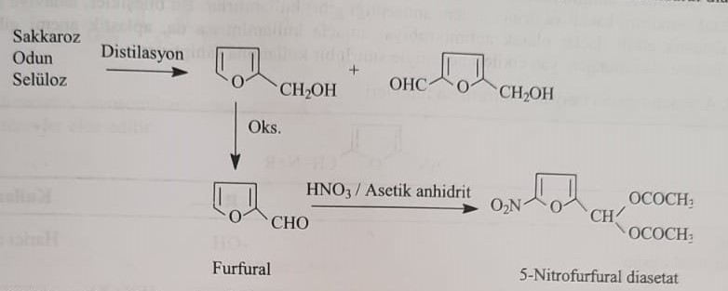

Most of the nitrofuran derivatives are used topically because resorption does not occur when taken orally. Drugs with resorption are found in a certain antimicrobial concentration in urine. This accumulation is not observed in any other organism tissue. In general, it is not used in bacterial infections of the urinary system. Bioavailability is around 40%. The toxicity of nitrofuran derivatives is low, side effects occur with long-term use and high doses. Side effects include nootropic disorders, eye darkening, dizziness, and hearing impairment. Mutagenic and consorogenic studies should be conducted before using these compounds.

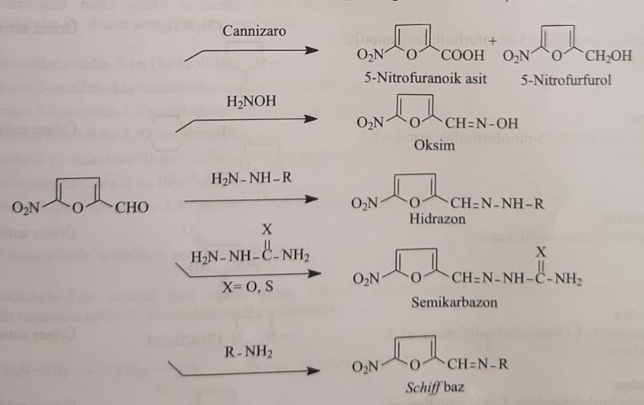

5-nitrofurfurol reacts with many aldehyde groups according to the following scheme. Many derivatives of 5-nitrofurfurol were synthesized on the basis of all these reactions. Its biological properties were investigated and included in the treatment. The pharmacodynamic properties of the compounds included in the treatment were improved, on the other hand, the physico-chemical properties of their pharmacokinetic properties were improved. These connections are divided into two main groups.

1) Containing azomethine group

2) Containing a vinyl group

Compounds containing the azomethine group

In this group of compounds, the aldehyde group of 5-nitrofurfural forms an azomethine bridge with acyclic or heterocyclic monoamines. In general, internal use of these compounds, which are known to have antimicrobial effects, is preferable to external use. Although these compounds were included in the treatment, they were presented as systemic drugs, but their use was limited because they caused additional effects, such as aplastic anemia.

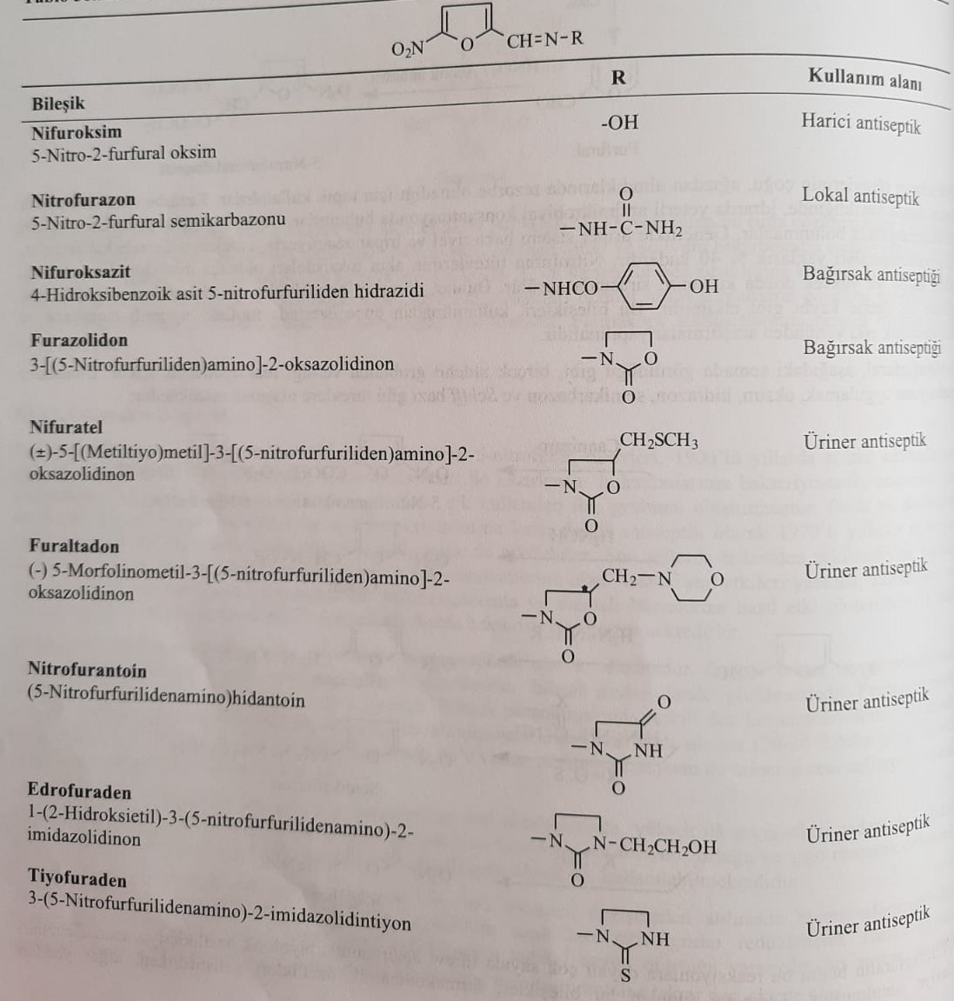

Nifurtimox drug

5-nitrofurfural diacetate is used as the main substance of 5-nitrofuran derivatives. Nitration of furfural by nitric acid and diacetate of 5-nitrofurfural is formed if this reaction is carried out in the medium of acetic anhydride.

The reaction of 5-nitrofurfural diacetate with thiosemicarboazide gives heterocyclic derivatives as a result of interaction with nitrofurazone and heterocyclic amines. The obtained derivatives obtained using heterocyclic amines as starting material in the synthesis of azomethine derivatives containing the following heterocyclic ring are shown.

1) 3-aminooxazolidon-2-one (furazolidone)

2) 3-amino-5-methylmercaptomethyl-oxazolidin-2-one (nifrotel)

3) amino-5-(morpholin-1-yl)-methyl-oxazolidin-2-one (furaltadone)

4) 3-aminoimidazolidine-2,5dione (nitrofurantoin)

5) 3-amino-1-(2-hydroxyethyl)-imidazolidin-2-one (edrofuraden)

6) 3-aminoimidazolidin-2-one (thiofuraden)

7) 4-amino-3-methyl-tetrahydro-1,4-thiazine-1,1-dioxide (nifurtimox)

The synthesis of the heterocycle is as follows:

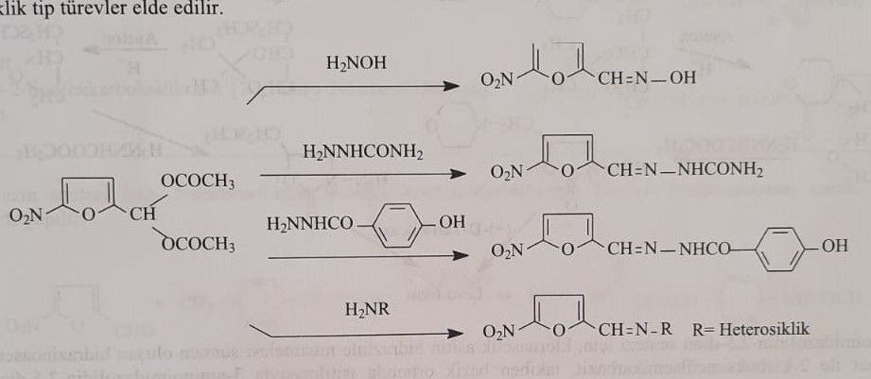

Those used in the reaction

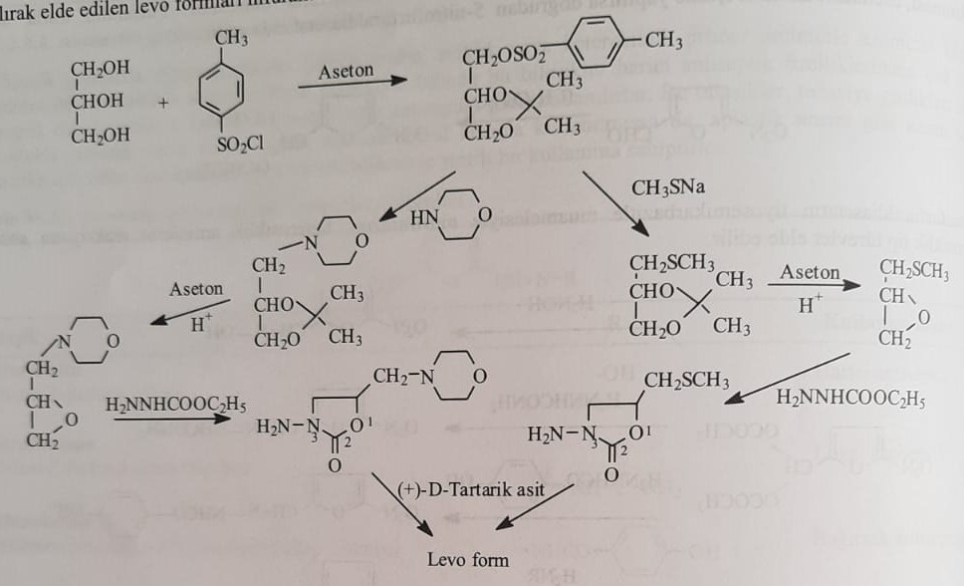

Nitrofurantoin synthesis

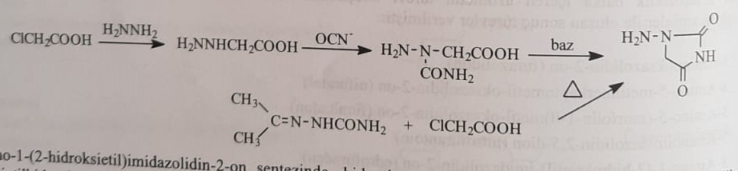

Endrofuroden synthesis

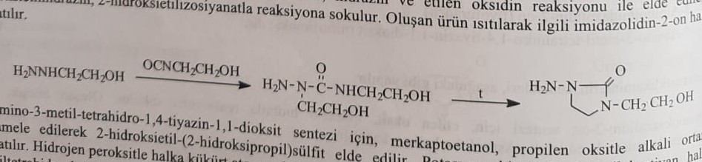

Nifurtimox synthesis

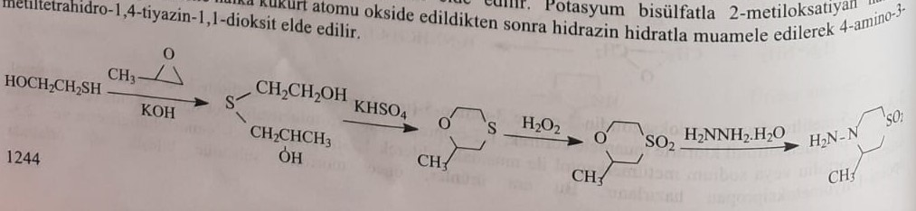

Vinyl group etiva makers

Nifurpyrazine and nifurzit drugs belong to this group.

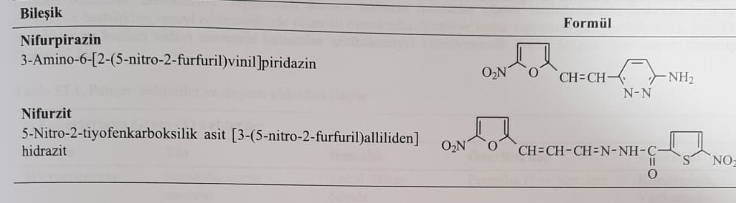

Synthesis of nifurpyrazine

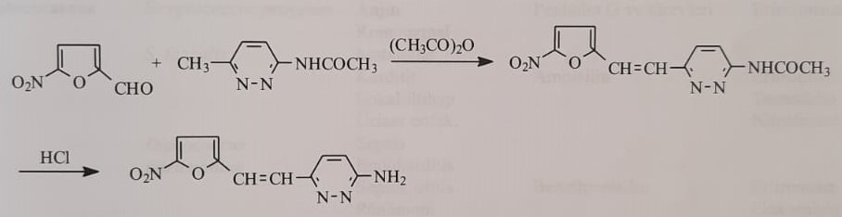

Nifurzide synthesis

